# EDUFLEX – A E-LEARNING PLATFORM

**Submitted in partial fulfilment of the**

**Requirements for the Degree of**

**MASTER OF COMPUTER APPLICATION**

**by**

**Sakshi Tyagi**

**2200290140133**

**Satyam Kesar**

**2200290140134**

**Under the Supervision of**

**Mr. Prashant Agrawal**

**(Associate Professor)**



**to the**

**Department of Computer Applications**

**DR. APJ ABDUL KALAM TECHNICAL UNIVERSITY, LUCKNOW**

**February, 2024**

**CERTIFICATE**

Certified that **Sakshi Tyagi 2200290140133, Satyam Kesar 2200290140134** have carried out the project work having “**Eduflex- A E-Learning Platform**” (**Mini Project-KCA353**) for **Master of Computer Application** from Dr. A.P.J. Abdul Kalam Technical University (AKTU**)** (formerly UPTU), Lucknow under my supervision. The project report embodies original work, and studies are carried out by the student himself/herself and the contents of the project report do not form the basis for the award of any other degree to the candidate or to anybody else from this or any other University/Institution.

**Date:**

**Sakshi Tyagi 2200290140133**

**Satyam Kesar 2200290140134**

This is to certify that the above statement made by the candidate is correct to the best of my knowledge.

Date:

**Mr. Prashant Agrawal Dr. Arun Tripathi**

**Associate Professor Head**

**Department of Computer Applications Department of Computer Applications**

**KIET Group of Institutions, Ghaziabad KIET Group of Institutions, Ghaziabad**

**AI Enabled Mock Interview System**

**Sakshi Tyagi, Satyam Kesar**

**ABSTRACT**

In the rapidly evolving landscape of education, the demand for flexible and accessible learning solutions has surged, prompting the development of robust e-learning platforms. This project endeavors to create an innovative e-learning platform tailored to meet the diverse needs of learners seeking to enhance their knowledge and skills in various domains. The platform incorporates comprehensive course offerings, interactive quizzes, and certification mechanisms to provide a holistic learning experience.

At the core of this e-learning platform is a sophisticated Content Management System (CMS) designed to curate and organize a vast array of courses spanning diverse subjects and levels of expertise. From foundational concepts to advanced topics, learners can explore a rich repository of multimedia content, including videos, presentations, and interactive simulations. The platform's intuitive user interface and personalized learning pathways empower users to navigate seamlessly through the course catalog, selecting modules that align with their interests and learning objectives.

Integral to the learning journey are interactive quizzes strategically interspersed throughout the courses. These quizzes serve as formative assessments, allowing learners to gauge their understanding of the material in real-time. Adaptive quiz algorithms dynamically adjust question difficulty based on individual performance, ensuring an optimal learning pace for each user. Additionally, immediate feedback and detailed explanations accompany quiz results, fostering a deeper understanding of concepts and facilitating self-directed learning.

Upon successful completion of courses and quizzes, learners have the opportunity to earn certifications, validating their mastery of the subject matter. These certifications are meticulously crafted to adhere to industry standards and best practices, enhancing learners' credibility and employability in their respective fields. Furthermore, the platform offers a seamless integration with professional accreditation bodies, enabling learners to obtain recognized credentials that hold value in the job market.

In conclusion, this e-learning platform represents a paradigm shift in education, offering a dynamic and engaging learning environment equipped with comprehensive course offerings, interactive quizzes, and industry-recognized certifications. By harnessing the power of technology to democratize education, this platform aims to empower learners worldwide to unlock their full potential and thrive in an increasingly competitive global landscape.

**ACKNOWLEDGEMENTS**

Success in life is never attained single-handedly. My deepest gratitude goes to my project supervisor, **Mr. Prashant Agrawal** for his guidance, help, and encouragement throughout my project work. Their enlightening ideas, comments, and suggestions.

Words are not enough to express my gratitude to Dr. Arun Kumar Tripathi, Professor and Head, Department of Computer Applications, for his insightful comments and administrative help on various occasions.

Fortunately, I have many understanding friends, who have helped me a lot on many critical conditions.

Finally, my sincere thanks go to my family members and all those who have directly and indirectly provided me with moral support and other kind of help. Without their support, completion of this work would not have been possible in time. They keep my life filled with enjoyment and happiness.

**Sakshi Tyagi**

**Satyam Kesar**

**TABLE OF CONTENTS**

|  |  |  |  |  |  |
| --- | --- | --- | --- | --- | --- |
|  | Certificate | | | | ii |
|  | Abstract | | | | iii |
|  | Acknowledgements | | | | iv |
|  | Table of Contents | | | | v |
| 1 | Introduction | | | | 1-5 |
|  | 1.1 | | Overview | | 1-2 |
|  | 1.2 | | Motivation | | 2-3 |
|  | 1.3 | | Problem Statement | | 2-4 |
|  | 1.4 | | Expected Outcome | | 4-5 |
| 2 | Literature Survey | | | | 6-7 |
| 3 | Design | | | | 8-11 |
|  | 3.1 | | Data Flow Diagram | | 8-9 |
|  |  | | 3.1.1 Level 0 DFD | | 8 |
|  |  | | 3.1.2 Level 1 DFD | | 9 |
|  | 3.2 | | ER Diagram | | 10 |
|  | 3.3 | | Use Case Diagram | | 10-11 |
|  |  | |
|  |  | |
|  |  | |
|  |  | |
|  |
|  |  | |
|  |  | |
|  |  | |
|  |  | |  |
|  |  | |  |
| 4 | Proposed Work | | | | 12-14 |
|  |
|  | 4.1 | Technology Description | | | 12 |
|  | 4.2 | Approach Used | | | 13 |
|  | 4.3 | Implementation Details | | | 13 |
|  | 4.4 | Challenges Faced | | | 14 |
| 5 | Results | | | | 15-18 |
|  | 5.1 | Screens and Explanation | | | 15 |
| 6 | Discussions | | | | 19-20 |
|  | 6.1 | Performance | | | 19-19 |
|  | 6.2 | Future Research Directions | | | 20-20 |
| 7 | Conclusion | | | | 21-22 |
| 8 | References | | | | 23 |
| 9 | Bibliography | | | | 24-25 |

**CHAPTER 1**

**INTRODUCTION**

* 1. **Overview**

Eduflex E-Learning Platform represents a transformative approach to education, offering a versatile and adaptive learning ecosystem equipped with comprehensive features to meet the diverse needs of learners worldwide. At its core, Eduflex provides a rich repository of courses covering a wide range of subjects, from foundational concepts to specialized topics. Leveraging cutting-edge content creation tools and instructional design principles, these courses are meticulously curated to deliver engaging and immersive learning experiences. Learners have the flexibility to explore courses aligned with their interests, career goals, and skill levels, empowering them to customize their learning journey to suit their unique needs. Whether seeking to acquire new skills, deepen their understanding of a particular subject, or advance their career prospects, Eduflex offers a pathway tailored to learners' aspirations. Embedded within the courses are interactive quizzes, serving as integral components of the learning experience. These quizzes offer learners an opportunity to assess their comprehension of the material in real-time, providing immediate feedback and insights to help track progress and identify areas for improvement. Adaptive algorithms tailor question difficulty to individual proficiency levels, ensuring a personalized learning experience that optimizes engagement and retention. Furthermore, detailed explanations accompany quiz results, facilitating a deeper understanding of concepts and promoting active learning.

One of the distinguishing features of Eduflex is its emphasis on certifications, recognizing the importance of credentials in validating learners' achievements and enhancing their credibility in the professional sphere. Upon successful completion of courses and quizzes, learners have the opportunity to earn industry-recognized certifications endorsed by reputable accreditation bodies. These certifications adhere to rigorous standards and serve as tangible evidence of mastery in a particular subject or skill area. By obtaining certifications through Eduflex, learners can bolster their resumes, differentiate themselves in the job market, and unlock new career opportunities. Additionally, Eduflex offers seamless integration with professional

accreditation bodies, ensuring that certifications obtained through the platform hold value and relevance in the industry.

Accessibility and flexibility are paramount to Eduflex's mission of democratizing education and making learning opportunities available to all. The platform is designed to be accessible anytime, anywhere, and on any device, allowing learners to engage with content at their own pace and convenience. Whether accessing Eduflex from a desktop computer, tablet, or smartphone, learners can seamlessly navigate courses, participate in quizzes, and obtain certifications without constraints. The user-friendly interface and intuitive navigation further enhance the learning experience, ensuring that learners can easily find and access the resources they need to succeed.

* 1. **Motivation**

The motivation behind the development of this innovative e-learning platform stems from a recognition of the evolving needs and demands within the educational landscape. Traditional educational models often struggle to accommodate the diverse schedules, preferences, and learning styles of modern learners. As technology continues to advance and globalization reshapes the job market, there is an increasing imperative to provide accessible, flexible, and effective learning solutions.

One of the primary motivations is to address the growing demand for lifelong learning. In today's fast-paced world, the acquisition of new skills and knowledge is not just desirable but essential for personal growth and professional advancement. However, traditional education systems often present barriers such as time constraints, geographical limitations, and financial burdens. This platform aims to break down these barriers by offering anytime, anywhere access to a comprehensive repository of courses.

Furthermore, there is a recognized need to enhance the engagement and effectiveness of online learning experiences. Passive consumption of content can lead to disengagement and limited retention of information. By incorporating interactive elements such as quizzes, simulations, and personalized learning pathways, this platform seeks to create a dynamic and immersive learning environment that fosters active participation and deeper comprehension.

Another key motivation is to address the demand for credible credentials in the job market. As industries evolve and new technologies emerge, employers increasingly value tangible evidence of skills and competencies. By offering industry-recognized certifications and seamless integration with professional accreditation bodies, this platform aims to provide learners with tangible credentials that enhance their credibility and employability.

Moreover, the democratization of education is a fundamental driving force behind this project. Access to quality education should not be limited by factors such as geographical location, socioeconomic status, or physical ability. By harnessing the power of technology, this platform seeks to empower learners worldwide to access high-quality educational resources and unlock their full potential, regardless of their background or circumstances.

In summary, the motivation behind this e-learning platform is rooted in the recognition of the changing educational landscape, the need for flexible and accessible learning solutions, the desire to enhance engagement and effectiveness in online learning, the demand for credible credentials in the job market, and the commitment to democratizing education on a global scale. Through this project, we aim to revolutionize the way individuals learn, grow, and succeed in an increasingly competitive and interconnected world.

* 1. **Problem Statement**

In the traditional educational paradigm, numerous challenges hinder the accessibility, effectiveness, and relevance of learning experiences. These challenges underscore the urgent need for a transformative solution that addresses the following key issues:

* **Limited Accessibility:** Traditional educational models often rely on physical classrooms and fixed schedules, creating barriers for individuals with diverse commitments and constraints. Geographical limitations further exacerbate this issue, particularly for learners residing in remote or underserved areas. Additionally, the high cost of education, including tuition fees and associated expenses, restricts access for many aspiring learners.
* **Engagement and Retention:** Passive learning approaches prevalent in traditional education fail to captivate learners' interest and foster deep comprehension. Lecture-based formats and static learning materials often result in disengagement, leading to low retention rates and ineffective learning outcomes. Moreover, the one-size-fits-all approach neglects the varied learning styles and preferences of learners, further diminishing engagement and effectiveness.
* **Credential Validation:** In today's competitive job market, employers seek tangible evidence of candidates' skills and competencies. However, the lack of standardized credentials and the proliferation of unaccredited courses undermine the credibility of online learning. Employers face challenges in evaluating the relevance and rigor of certifications obtained through various e-learning platforms, leading to skepticism regarding their value.
* **Skills Gap and Industry Relevance:** Rapid technological advancements and evolving industry demands create a widening gap between traditional educational curricula and the skills required in the workforce. Many educational institutions struggle to adapt their offerings to keep pace with industry trends and emerging technologies. As a result, learners often graduate with outdated skills that do not align with market needs, leading to mismatches between job seekers' capabilities and employers' requirements.
* **Exclusionary Practices and Inequities:** Socioeconomic disparities and systemic inequalities perpetuate exclusionary practices within the education system. Marginalized communities, including low-income individuals, ethnic minorities, and people with disabilities, face disproportionate barriers to accessing quality education and opportunities for advancement. These disparities contribute to widening socioeconomic gaps and hinder efforts to promote diversity and inclusion in the workforce.

Addressing these multifaceted challenges requires a holistic approach that leverages technology, innovation, and collaboration across various stakeholders. By developing an e-learning platform that prioritizes accessibility, engagement, credibility, relevance, and inclusivity, we can pave the way for a more equitable, effective, and responsive educational ecosystem. Through this project, we endeavor to empower learners worldwide to overcome barriers, acquire valuable skills, and thrive in an increasingly dynamic and interconnected global landscape.

* 1. **Expected Outcome**

The envisioned outcome of this project is a groundbreaking e-learning platform that revolutionizes the landscape of education by addressing the aforementioned challenges and delivering tangible benefits to learners, educators, and employers alike. The anticipated outcomes include:

* Enhanced Accessibility: The e-learning platform will provide anytime, anywhere access to a diverse range of high-quality educational resources, breaking down geographical barriers and accommodating the diverse schedules and preferences of learners. By democratizing access to education, the platform will empower individuals from all backgrounds to pursue their learning goals and unlock their full potential.
* Improved Engagement and Learning Outcomes: Through interactive content, personalized learning pathways, and adaptive assessment mechanisms, the platform will foster active participation, deep comprehension, and sustained motivation among learners. By catering to different learning styles and preferences, the platform will enhance engagement and retention, leading to more effective learning outcomes.
* Credible Credentials and Recognition: The integration of industry-recognized certifications and accreditation mechanisms will enhance the credibility and value of the learning experiences offered on the platform. Learners who successfully complete courses and obtain certifications will gain tangible evidence of their skills and competencies, increasing their credibility and employability in the job market.
* Alignment with Industry Needs: The platform will offer courses and content that are continuously updated to reflect the latest industry trends, technological advancements, and emerging skill requirements. By bridging the gap between educational curricula and industry needs, the platform will equip learners with relevant, up-to-date skills that are in high demand in the workforce, thereby increasing their competitiveness and career prospects.
* Promotion of Inclusivity and Diversity: By prioritizing inclusivity and diversity in course offerings, instructional design, and outreach initiatives, the platform will create a more equitable and inclusive learning environment. Special attention will be given to addressing the needs of marginalized communities and underserved populations, thereby reducing socioeconomic disparities and promoting social mobility.
* Global Impact and Scalability: The scalability and accessibility of the e-learning platform will enable it to reach learners worldwide, regardless of their geographical location or socioeconomic status. By harnessing the power of technology and digital connectivity, the platform will have a transformative impact on education at a global scale, empowering individuals and communities to thrive in the knowledge economy.

**CHAPTER 2**

**LITERATURE SURVEY**

This study delves into the realm of enhancing engagement within e-learning environments by exploring the efficacy of interactive content. Through the analysis of various interactive elements like simulations, games, and virtual labs, the research aims to elucidate their impact on learner motivation, participation, and retention of information. The findings extracted from this research serve to illuminate best practices in incorporating interactive content within course materials to optimize educational outcomes and foster deeper engagement among learners.

Within the domain of adaptive e-learning platforms, this paper proposes a structured framework for crafting personalized learning pathways. By tailoring learning experiences to individual learners' unique needs, preferences, and proficiency levels, the framework aims to enhance engagement, satisfaction, and overall learning outcomes. It underscores the significance of leveraging data-driven algorithms and learner analytics to dynamically adjust course content, pacing, and assessments, thereby facilitating an optimized learning experience personalized for each user.

Through a comparative study, this research endeavors to evaluate the validity and reliability of diverse online assessment methods employed in e-learning environments. It scrutinizes the effectiveness of various assessment approaches such as quizzes, exams, and project-based evaluations in accurately gauging learner performance and providing meaningful feedback. The insights gleaned from this study contribute to the refinement of assessment strategies aligned with the instructional objectives and learning goals of online courses.

This research paper delves into the realm of online learning certifications, scrutinizing the standards, practices, and implications associated with their issuance. It delves into the credibility and validity of online certifications, the accreditation process, and their impact on learners' career trajectories and employability prospects. By shedding light on these aspects, the research offers invaluable insights into designing and administering certification programs that uphold industry standards while meeting the needs of learners.

Addressing the pressing issue of the skills gap, this paper investigates strategies for aligning e-learning curricula with the evolving demands of industries and employers. It explores methodologies for identifying emerging skills gaps, updating course offerings, and integrating industry-relevant content into online learning programs. Through collaboration between educators, industry professionals, and policymakers, the research advocates for e-learning programs that effectively equip learners with the skills required to thrive in the modern workforce.

Accessibility in e-learning environments is scrutinized in this study, which aims to identify challenges, propose solutions, and advocate for best practices in designing inclusive online learning experiences. It addresses issues such as adherence to web accessibility standards, utilization of assistive technologies, and incorporation of universal design principles. By emphasizing the importance of accessibility, the research advocates for e-learning platforms that cater to learners with disabilities and diverse learning needs.

This research paper explores the intricate interplay between socioeconomic status and participation in e-learning programs, as well as its repercussions on learning outcomes. It delves into factors such as access to technology, internet connectivity, and financial resources that shape learners' ability to engage in online education. By shedding light on these disparities, the research underscores the imperative of implementing strategies to bridge the socioeconomic gap and ensure equitable access to e-learning opportunities.

Cultural diversity within online learning environments is the focal point of this study, which investigates the challenges and opportunities presented by diverse cultural backgrounds. It examines issues ranging from language barriers to disparities in learning styles and advocates for the inclusion of culturally relevant content and instructional approaches. By fostering a culturally inclusive learning environment, the research emphasizes the importance of respecting and celebrating diversity within e-learning platforms.

This paper delves into the integration of technology within educational practices, exploring pedagogical approaches that harness digital tools, multimedia resources, and collaborative platforms to enhance learning experiences. It investigates the impact of technology integration on student engagement, critical thinking, and knowledge construction. Through the identification of effective strategies, the research advocates for the judicious use of technology to facilitate enriched learning outcomes.

Through a comprehensive systematic review, this research synthesizes existing literature on the effectiveness of e-learning platforms in achieving educational objectives. It identifies key factors contributing to the success of e-learning initiatives, ranging from instructional design to learner engagement strategies and assessment methods. By distilling these findings, the research offers practical recommendations for optimizing the design and implementation of e-learning platforms to maximize their educational impact.

**CHAPTER 3**

**DESIGN**

**3.1 Data Flow Diagram**

**3.1.1 Level 0 Data Flow Diagram**

Level 0 Data Flow Diagram will explain the basic flow of data in a system which shows how the new or old user will interact with the system.

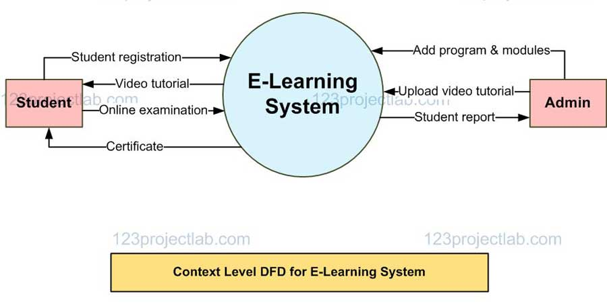

Fig. 3.1 Level 0 DFD of Eduflex

Fig. 3.1 elaborates the interaction between user and the system. If the user is new then user will first register to the system by providing name, username, email, password. Once successfully registered a message will be display to the user of successfully registered. If the user is old, then they can directly login to the system. Once successfully logged into the system, it will provide a message to the user. Then the user will provide the domain and type of course, based on that information system will provide you set of quizzes, that user need to answer. System will also provide the feedback simultaneously.

**3.1.2 Level 1 Data Flow Diagram**

Level 1 Data Flow Diagram will explain the basic flow of data in a system which shows how the new or old user will interact with the system with different processes.

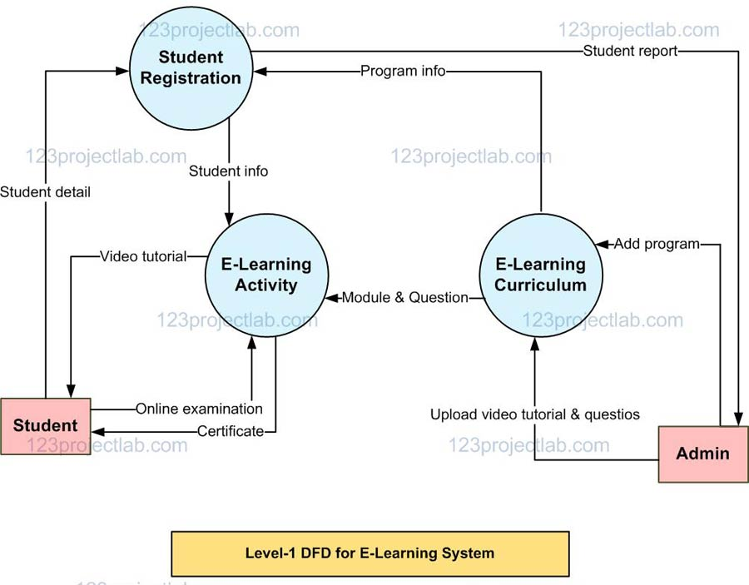

Fig. 3.2 Level 1 DFD of Eduflex

Fig. 3.2 explains the entire flow of user and system with all processes involved in the system. If the user is new to the system, then register to the system by providing the details to it. And all the details of the user will be stored in the database. If the user is old, then user will log into the system by email and password which will be validated from the database. Then the user will provide the course, quizzes and certification. After the selected the course will take the content to the user then feedback is generated and given to the user.

**3.2 ER Diagram**

An Entity Relationship Diagram is a diagram that represents relationships among entities in a database.

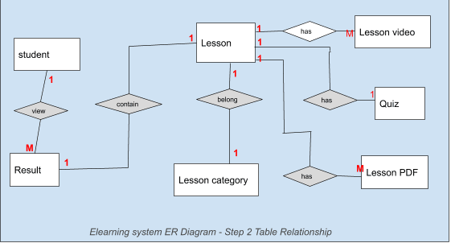

**3.3 Use Case Diagram**

In Use Case Diagram we elaborate about the purpose, actor, pre-condition, post-condition, basic flow, and alternate flow of all the use cases. In our system there are two actors, one is a user and other is the admin who interacts with the use cases of the course and quizzes. It explains the details and conditions of the system to be fulfilled in order to successfully complete each use case.

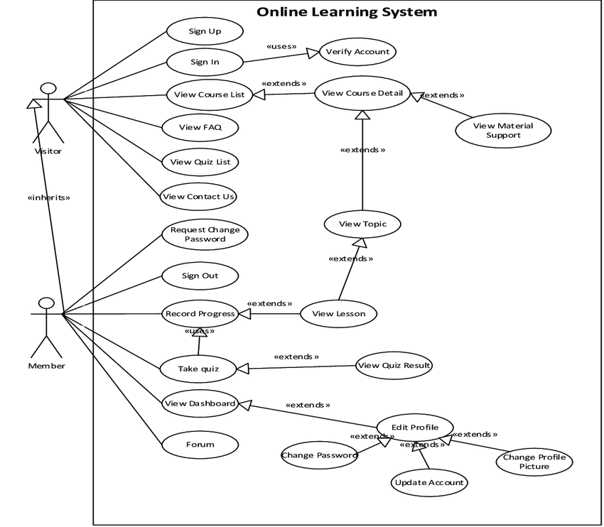

Fig. 3.7 Use Case Diagram of Eduflex

**CHAPTER 4**

**PROPOSED WORK**

**4.1 Technology Description**

* **Selection of Operating System:** Our website is platform independent, so it does not depend on the operating system.
* **Selection of Software:** Visual Studio is used to create our software.
* **Languages Used:** React JS, firebase.

**4.2 Approach Used**

Eduflex is an e-learning platform designed to offer a diverse range of courses and quizzes to users. The platform is built using React.js and JavaScript for the frontend, with Firebase serving as the backend infrastructure.

**4.2.1 Objectives**

1. To create an intuitive and user-friendly interface for browsing courses and taking quizzes.

2. To implement a quiz grading system that awards certificates upon achieving a passing score of 75%.

3. To ensure scalability and reliability through the use of Firebase for backend services.

**4.2.2 Technologies Used**

* **Frontend:** React.js, JavaScript, HTML, CSS.
* **Backend:** Firebase (Authentication, Firestore, Cloud Functions)

**4.2.3 Features**

**1. Course Catalog:** Users can browse through a variety of courses organized by category.

**2. Quiz Module:** Each course contains quizzes to test the user's knowledge.

**3. Grading System:** Quizzes are graded automatically, and certificates are awarded upon achieving a passing score of 75%.

**4. User Authentication:** Users can create accounts, login, and track their progress.

**5. Dashboard:** Users have access to a personalized dashboard where they can view their enrolled courses, quiz results, and earned certificates.

**4.3 Implementation Details**

**1. Frontend Development:** Utilized React.js to create a dynamic and responsive user interface.

**2. Backend Services:** Leveraged Firebase for user authentication, database management (Firestore), and serverless functions (Cloud Functions).

**3. Quiz Logic:** Implemented algorithms to grade quizzes and determine certificate eligibility based on user performance.

**4. User Authentication:** Integrated Firebase Authentication to manage user accounts securely.

**5. Data Management:** Stored course content, user progress, and quiz results in Firestore for efficient data retrieval and management.

**4.4 Challenges Faced**

**1. Scalability:** Ensuring the platform can handle a growing user base and course catalog.

**2. Security:** Implementing robust authentication and authorization mechanisms to protect user data.

**3. Performance Optimization:** Optimizing frontend and backend code for faster loading times and smoother user experience.

**4.5 Future Enhancements**

**1. Interactive Learning Tools:** Introduce interactive elements such as quizzes with multimedia content.

**2. Social Features:** Incorporate social features like discussion forums and peer-to-peer learning communities.

**3. Advanced Analytics:** Implement analytics to track user engagement and course effectiveness.

**4. Mobile App Development:** Extend the platform with native mobile apps for iOS and Android devices.

**CHAPTER 5**

**RESULTS**

* 1. **Screens and Explanations**

This chapter will include all the screens available in the project such as home page, registration page, login page, course, quizzes and cetification along with detailed explanation of each screen and its functionality. Screens available in the system are as follows:

**Screen 1: Home Page**

Screen 1 is the home page of the website which displays the basic information about the course that show preparation is important and what our system will provide. From this home page you can log in or register to the system to start your courses.

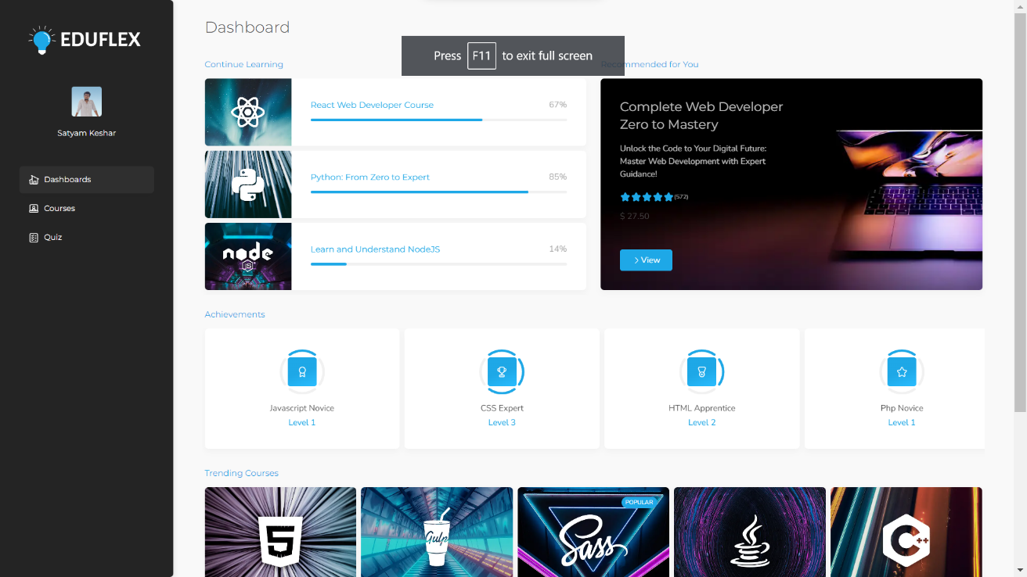

Fig. 5.1 Home Page

**Screen 2: Login and Registration Screen**

Screen 2 is the log in and the registration page. Where if the user is new to the system, then he or she can register themselves to the system by providing the name, email and password. Password validation is also done at the time of registration. If the user is not new or already registered to the system, then he or she can directly log in to the system by proving some credentials such as email and password. The user can toggle between the login and the registration page.

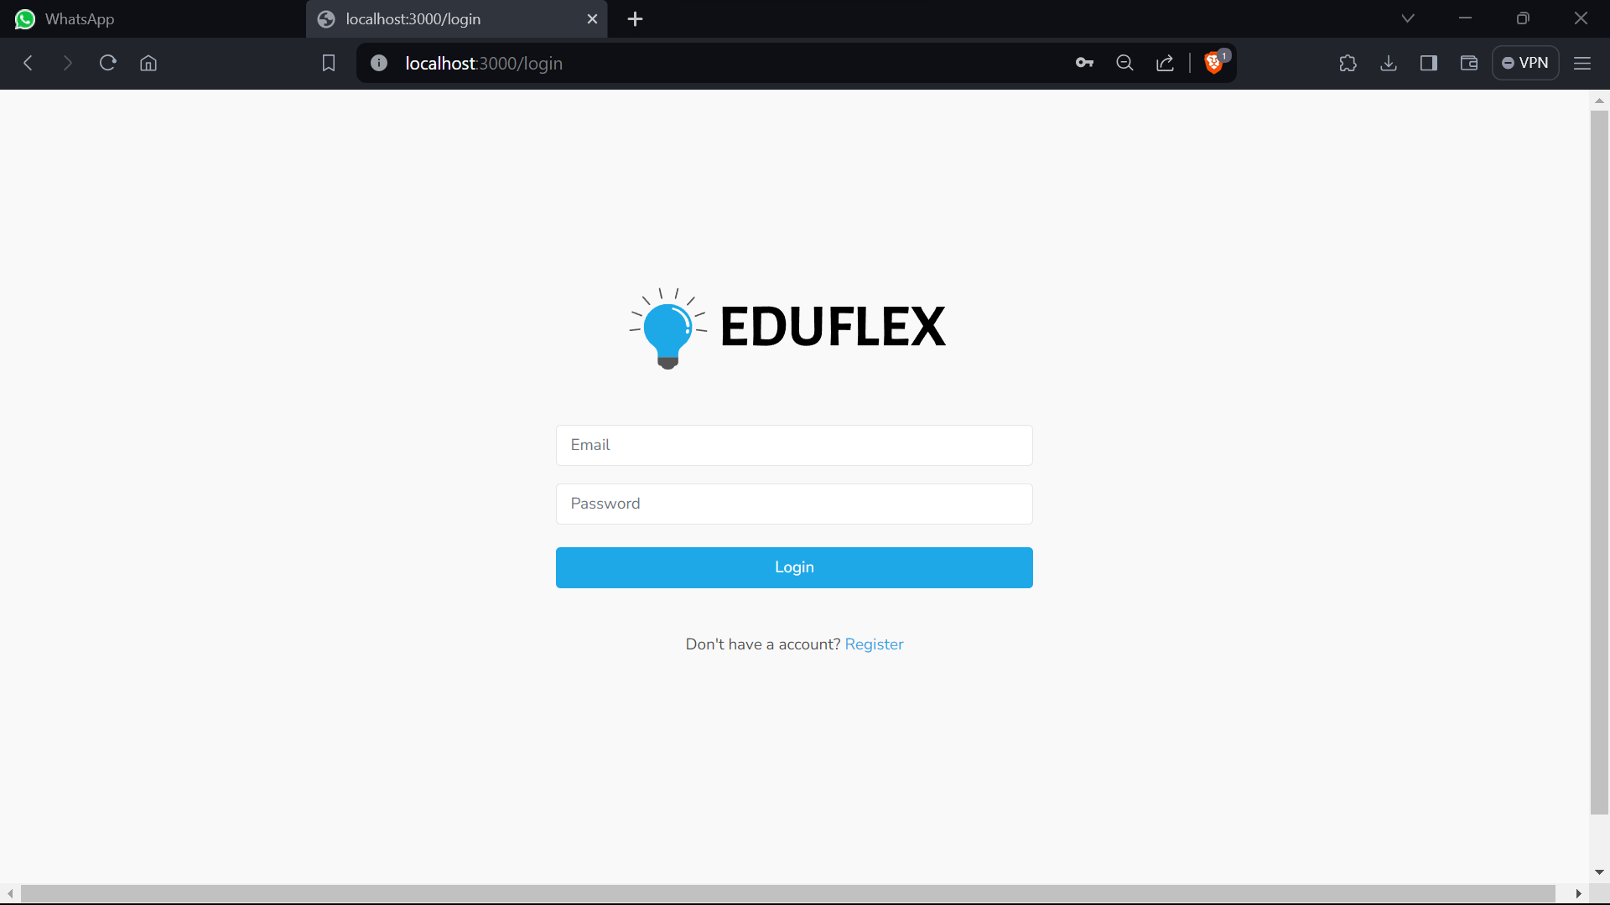

Fig. 5.2 Login and Registration Screen

**Screen 3: Quizzes**

Screen 3 is the page of quizzes user successfully logged into the system then the user can start the new quizzes by clicking on the button “Start New Quizzes” and history of the quizzes are also visible at this page only.

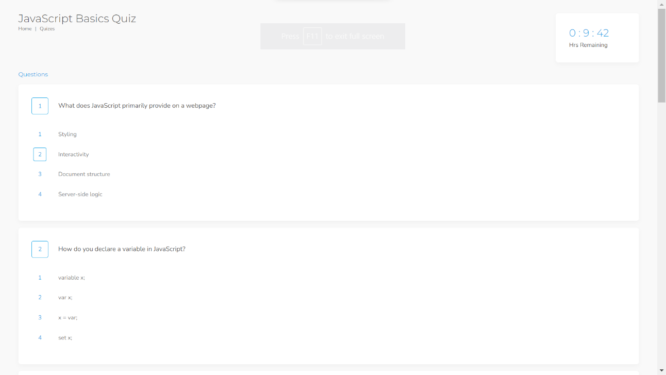

Fig. 5.3 quizzes

**Screen 4: Certification**

Screen 4 is show the certified. If you scored 75% in quizzes then you get the certified. Each certified have unique id and you will get the certified with in a second.

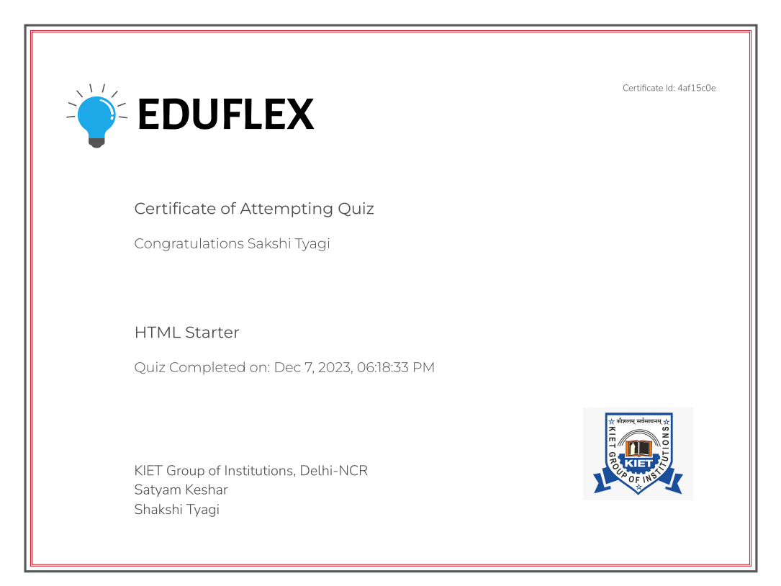

Fig. 5.4 certification

**CHAPTER 6**

**DISCUSSIONS**

The Discussions section of this report delves into crucial aspects of the Eduflex- A E-LEARNING PLATFORM, shedding light on the strategic choices and implications for user experience, scalability, and future developments. The technological integration within the MERN stack is highlighted, flexibility and scalability, React for its declarative and crucial for real-time interactions.

**6.1 Performance**

The success of the Eduflex – A E-learning Platform System is contingent upon the effective and efficiency of the underlying responsible for generating course, quizzes, certification and providing feedback.

* React.js optimizes frontend rendering, resulting in rapid loading of course materials and quizzes.
* Firebase's scalable architecture accommodates growing user bases and course catalog sizes without compromising performance.
* Firebase's real-time database capabilities facilitate instant updates, ensuring users receive prompt feedback on quiz results and course program.
* The combination of React.js and Firebase offers a stable platform, minimizing downtime and interruptions to the learning process.
* Firebase's Firestore efficiently manages user data and course content, contributing to smooth navigation and access to resources.
* React.js enables a responsive user interface, allowing Eduflex to deliver a consistent experience across devices and screen sizes.
* Firebase's serverless functions optimize backend operations, enhancing overall system performance and responsiveness.
* Eduflex optimizes resource usage, minimizing server load and network requests for improved system efficiency.

**6.3 Future Research Directions**

Our System is initial stage of the E-learning platform. So, there is a lot of scope to enhance the system in system. Here are some research directions that should be considered in the future.

**1. *Personalized Learning Paths:** Explore algorithms and machine learning techniques to analyze user behavior, preferences, and performance data. By leveraging this information, Eduflex can recommend personalized learning paths tailored to individual learners' needs and goals, enhancing the overall learning experience.

**2. Gamification and Engagement Strategies:** Investigate the integration of gamification elements, such as badges, leaderboards, and interactive challenges, to enhance user engagement and motivation. Researching effective gamification strategies can further incentivize participation and promote active learning among users.

**3. Adaptive Assessment Methods:** Research and develop adaptive assessment methods that dynamically adjust quiz difficulty based on learners' proficiency levels and performance. By providing tailored assessments, Eduflex can ensure that users are appropriately challenged while minimizing frustration and maximizing learning outcomes.

**4. Augmented Reality (AR) and Virtual Reality (VR) Integration:** Explore the integration of AR and VR technologies to create immersive learning experiences. Researching the potential applications of AR and VR in educational contexts can open up new avenues for interactive simulations, virtual laboratories, and experiential learning opportunities within Eduflex.

**5. Accessibility and Inclusivity:** Investigate strategies for enhancing accessibility and inclusivity within Eduflex to cater to diverse learner populations, including those with disabilities or special learning needs. Researching best practices for designing accessible interfaces, providing alternative formats for course content, and implementing assistive technologies can ensure that Eduflex remains accessible to all users.

6**. Social Learning Networks:** Explore the integration of social learning networks and collaborative tools within Eduflex to facilitate peer-to-peer interaction, knowledge sharing, and community building. Researching the design and implementation of social features such as discussion forums, group projects, and mentorship programs can foster a sense of belonging and collaboration among learners.

**CHAPTER 7**

**CONCLUSION**

The culmination of our efforts in developing Eduflex marks a significant milestone in the landscape of e-learning platforms. By harnessing the power of React.js, JavaScript, and Firebase, we have crafted a versatile and robust platform that seamlessly integrates courses and quizzes, providing users with an immersive and engaging learning experience.

At the heart of Eduflex lies its innovative grading system, which automatically evaluates quiz performance and rewards users who achieve a minimum score of 75% with certificates. This feature not only serves as a tangible acknowledgment of learners' accomplishments but also motivates them to strive for excellence and pursue further educational endeavors.

The utilization of React.js has been instrumental in creating an intuitive and responsive user interface, ensuring seamless navigation and accessibility across a wide range of devices. Additionally, Firebase has emerged as a reliable and scalable backend solution, facilitating streamlined user authentication, data management, and serverless functions.

Throughout the development journey, we encountered and surmounted various challenges, ranging from scalability and security to performance optimization. Through meticulous planning, collaboration, and iterative refinement, we have successfully addressed these obstacles, thereby fortifying the platform's stability and efficiency.

Looking ahead, we envision Eduflex evolving into a multifaceted learning ecosystem, enriched by the incorporation of advanced features and functionalities. These enhancements include the integration of interactive learning tools, social engagement features, and sophisticated analytics capabilities, all of which are aimed at further enhancing the user experience and maximizing learning outcomes.

Interactive learning tools, such as interactive quizzes with multimedia content, simulations, and virtual labs, will provide users with immersive learning experiences that cater to diverse learning styles and preferences. By fostering interactivity and engagement, these tools will deepen users' understanding of course material and promote active participation in the learning process.

Social engagement features, such as discussion forums, peer-to-peer collaboration tools, and user-generated content sharing capabilities, will foster a sense of community and collaboration among learners. By facilitating knowledge sharing, peer support, and collaborative learning experiences, these features will enrich the learning journey and promote a culture of continuous growth and development.

Sophisticated analytics capabilities will provide valuable insights into user engagement, learning progress, and course effectiveness. By leveraging data analytics and machine learning algorithms, we can identify patterns, trends, and areas for improvement, thereby enabling data-driven decision-making and continuous optimization of the platform.

In conclusion, Eduflex is not just an e-learning platform—it is a testament to our commitment to innovation, excellence, and empowerment in the field of online education. As we continue to iterate, innovate, and expand the platform's capabilities, we remain steadfast in our dedication to empowering learners worldwide on their journey towards knowledge acquisition, skill development, and personal growth. With Eduflex, the possibilities for learning are limitless, and the future of education is brighter than ever before.

**CHAPTER 8**

**REFERENCES**

* <https://www.learnupon.com>
* https://developer.mozilla.org/en-US/
* Akyol, Z., & Garrison, D. R. (2011).
* Dziuban, C., Hartman, J., Cavanagh, T. Moskal, P., (2011).
* React.js Documentation: [https://reactjs.org/docs/getting-started.html](https://reactjs.org/docs/getting-started.html)
* Firebase Documentation: [https://firebase.google.com/docs](https://firebase.google.com/docs)

**CHAPTER 9**

**BIBLIOGRAPHY**

1. Clark, R. C., & Mayer, R. E. (2016). E-Learning and the Science of Instruction: Proven Guidelines for Consumers and Designers of Multimedia Learning. John Wiley & Sons.

2. Rosenberg, M. J. (2001). E-Learning: Strategies for Delivering Knowledge in the Digital Age. McGraw-Hill Education.

3. Piskurich, G. M. (2015). Rapid Instructional Design: Learning ID Fast and Right (3rd ed.). John Wiley & Sons.

4. Bates, A. W., & Sangrà, A. (2011). Managing Technology in Higher Education: Strategies for Transforming Teaching and Learning. John Wiley & Sons.

5. Siemens, G. (2005). "Connectivism: A Learning Theory for the Digital Age." International Journal of Instructional Technology and Distance Learning, 2(1), 3-10.

6. Anderson, T. (2008). Theory and Practice of Online Learning. Athabasca University Press.

7. Laurillard, D. (2002). Rethinking University Teaching: A Framework for the Effective Use of Educational Technology. Routledge.

8. Downes, S. (2005). "E-Learning 2.0." eLearn Magazine, 2005(10), 1-12.

9. Koohang, A., & Harman, K. (Eds.). (2005). Learning Objects: Theory, Praxis, Issues, and Trends. Informing Science Press.

10. Siemens, G., & Tittenberger, P. (2009). Handbook of Emerging Technologies for Learning. University of Manitoba Press.